



Short Lab Title
LAB MANUAL

Disclaimer: The content is curated from online/offline resources and used for educational purpose only
Lab1. Create Azure Account and Explore Azure Portal
Objective:
• To create a Microsoft Azure account.
• To understand the interface and main features of the Azure Portal.
• To explore basic services such as Resource Groups, Virtual Machines, and Storage in Azure.
Equipment Required:
• Computer or Laptop
• Internet Connection
• Web Browser (Google Chrome / Microsoft Edge / Firefox)
• Valid Email ID and Mobile Number for account verification
Prerequisites:
• Basic understanding of cloud computing concepts
• A Microsoft account (Outlook/Hotmail) or any valid email address to create one
• Stable internet connection
Problem Statement:
Cloud computing platforms allow users to access computing resources such as storage, networking, and virtual machines through the internet. Microsoft Azure is one of the leading cloud platforms. In this lab, students will create a Microsoft Azure account and explore the Azure Portal to understand its dashboard, services, and management features.
Procedure:
Step 1: Create a Microsoft Azure Account
- Open a web browser.
- Go to the Azure website: https://azure.microsoft.com
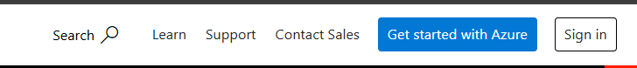
- Click on Start Free or Try Azure for Free.
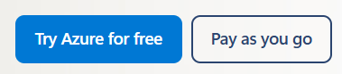
- Sign in using an existing Microsoft account or create a new one.
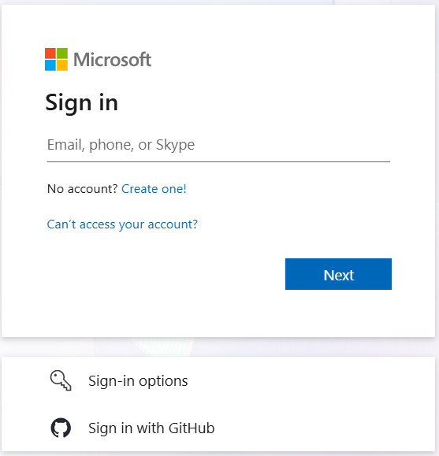
- Enter the required details such as:
  - Email ID
  - Phone number
  - Country/Region
- Complete the identity verification using the phone number.
- Enter payment details (required for verification, free credits may be provided).
- Accept the terms and conditions.
- Click Sign Up to create the Azure account.
Step 2: Access Azure Portal
- Open the Azure Portal: https://portal.azure.com
- Sign in using the Microsoft account credentials.
- The Azure Dashboard will appear.
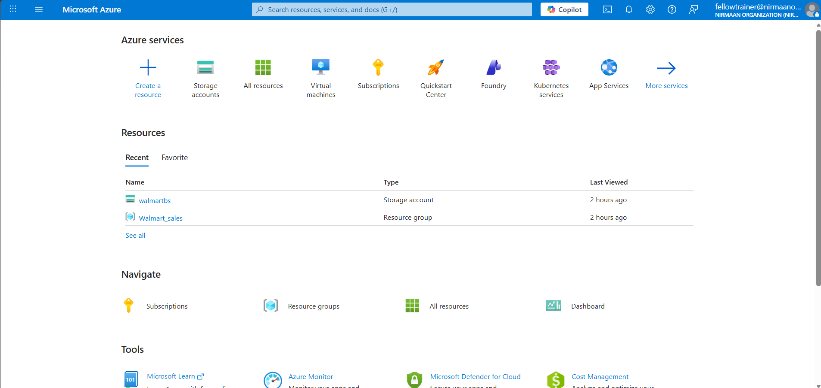
Step 3: Explore Azure Portal Interface
Observe the main components of the portal:

• Dashboard – Overview of services and resources
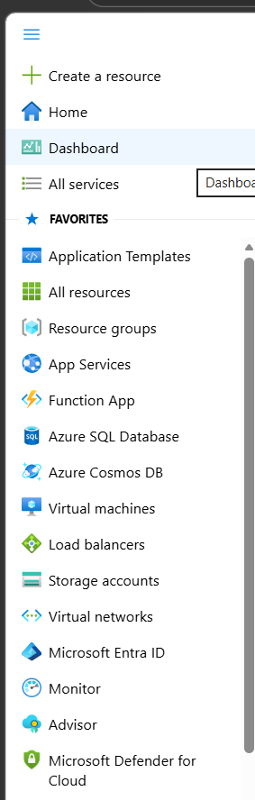
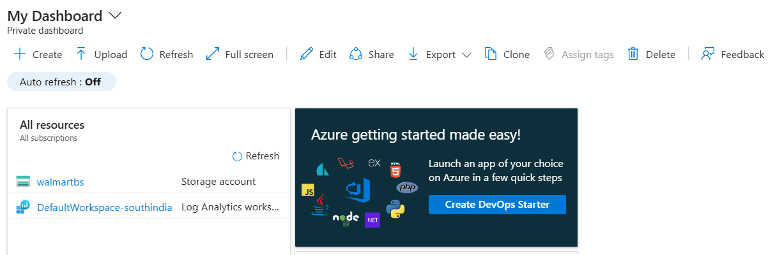
• Navigation Menu (Left Panel) – Access Azure services

• Search Bar – Quickly find services and resources
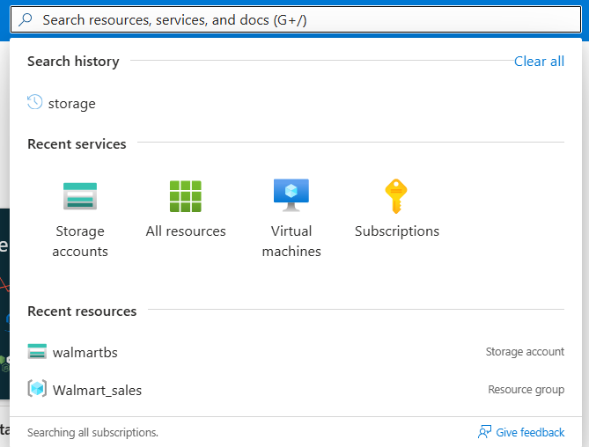
• Resource Groups – Manage related resources
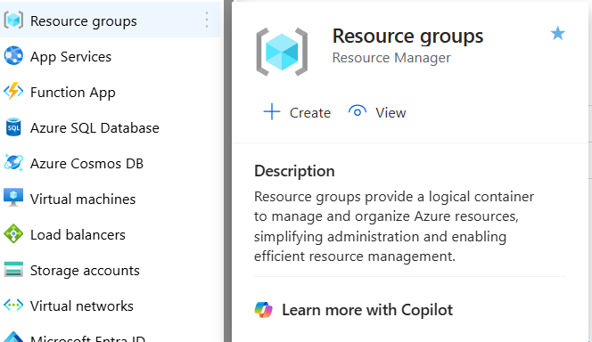
• Notifications – View alerts and updates
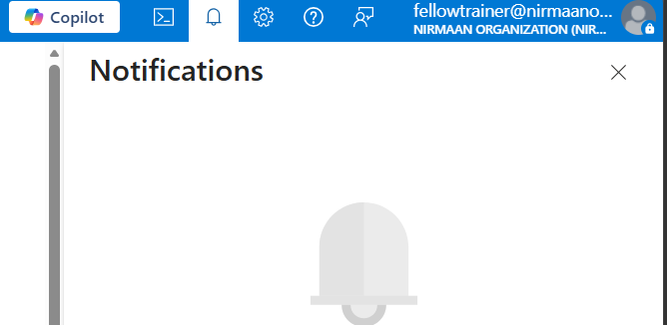

Step 4: Explore Key Azure Services
- In the search bar, type Virtual Machines and open it.
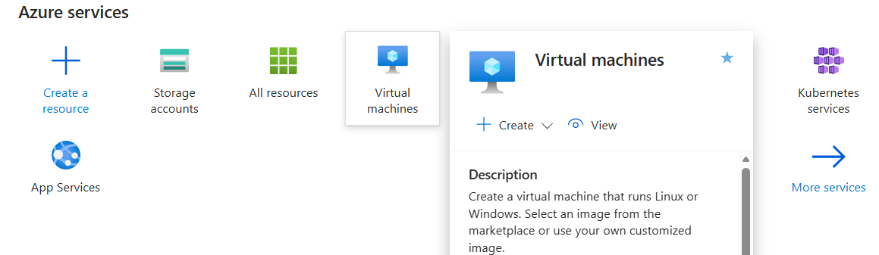
- Click Create to see VM creation options.
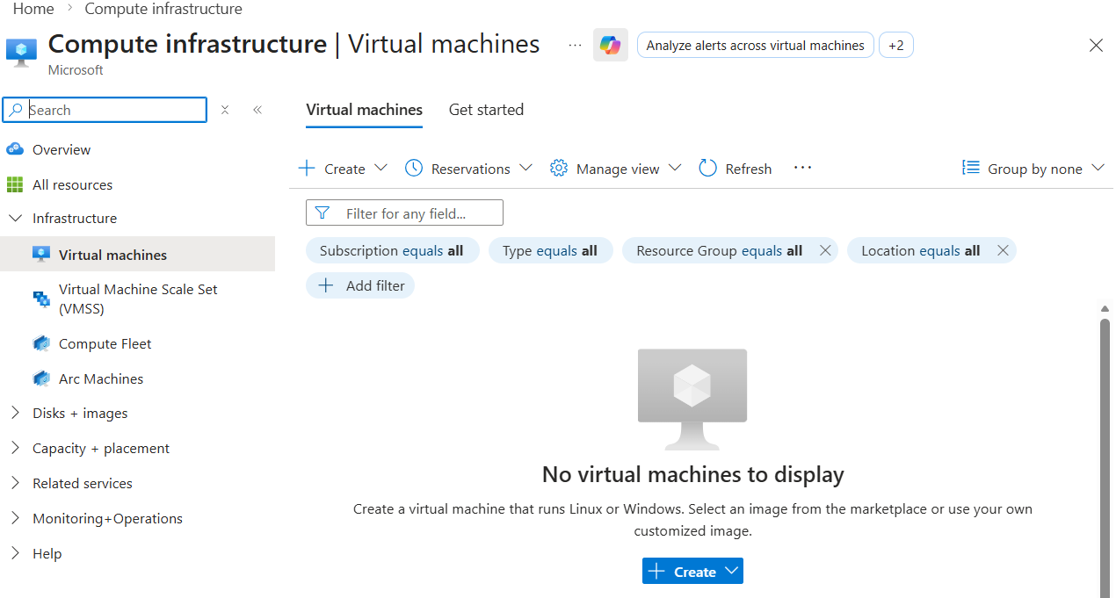
- Go back to the search bar and search for Storage Accounts.
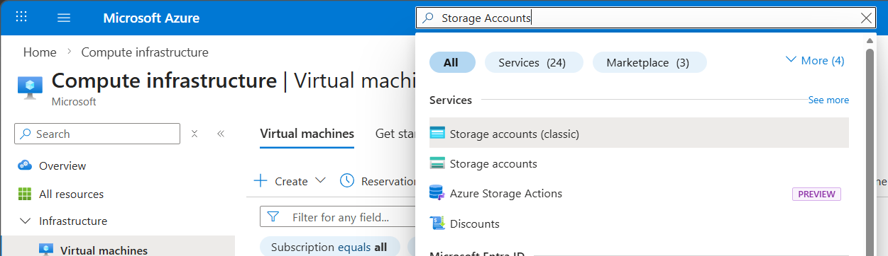
- Observe storage options and configurations.
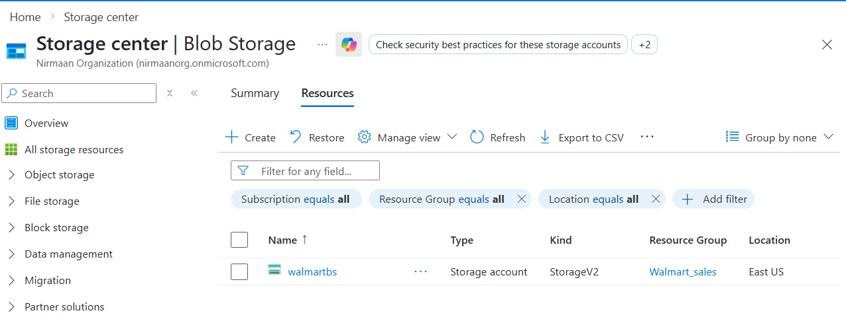
- Search for Resource Groups and view the management page.
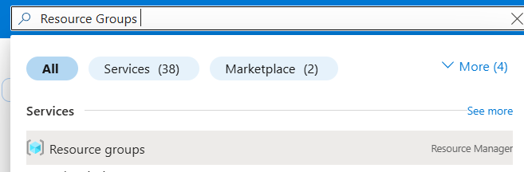
Conclusion:
In this lab, we successfully created a Microsoft Azure account and logged into the Azure Portal. We explored the dashboard, navigation panel, and basic services such as Virtual Machines, Storage Accounts, and Resource Groups. This lab helps in understanding how Azure provides cloud services through an easy-to-use web interface.

